End-to-End Harness CI/CD Pipeline for Spring Boot Application Deployment on Minikube:

Objective:
To automate the complete lifecycle of a Spring Boot application—from code commit to deployment on a Minikube cluster—using Harness CI/CD. This includes:
- Continuous Integration (CI):
  - Clone the GitHub repository
  - Compile and test the Spring Boot application using Maven
  - Package the application as a JAR
  - Build and push a Docker image to Docker Hub
- Continuous Deployment (CD):
  - Deploy the Docker image to a Minikube Kubernetes cluster
  - Use Kubernetes manifests (Deployment & Service) to manage pods and services
  - Enable environment-specific deployment via Harness Environments and Infrastructure definitions
  - Allow external access to the Spring Boot application via NodePort, LoadBalancer, or SSH tunneling
Outcome:
- Fully automated CI/CD pipeline in Harness that ensures reliable, repeatable, and traceable deployments.
- Separation of concerns via Service, Environment, and Infrastructure, enabling reusability and multi-environment deployments.

Step 1 — Sign in & Select Project:
Objective: Ensure you are working in the correct Harness project.
Steps:
- Open Harness and sign in using your account.
- In the top-left project/org selector:
  - Organization: default
  - Project: default_project (or create/select the one you want)
Usage: All pipelines, secrets, connectors, and deployments are scoped to this project.

Step 2 — Prep in Harness — What we’ll create:
We will create (order matters):
- Secrets (Docker Hub token, GitHub PAT if needed).
- Connectors: GitHub connector (to clone repo), Docker Registry connector (Docker Hub), Kubernetes Cluster connector (to target Minikube).
- Delegate (required) — install a Harness Delegate into your Minikube (or a host that can reach Minikube) so Harness can talk to the cluster.
- CI pipeline that: clones code, runs Maven tests, packages jar, builds and pushes Docker image.
- CD (Deployment): a Harness Service + Environment using the K8s connector and manifests from Git, and a CD Pipeline/Stage to apply manifests.
(Helpful docs: how to add GitHub connector / GitHub App support, Docker build & push step, delegate and k8s manifests are in Harness docs). (Harness)

Step 3 — Add Secrets:
- Objective: Store sensitive data like tokens securely for use in pipelines.
- Steps:
- Navigate to Project Settings → Secrets → New Secret → Text.
- Create the following:
  - GITHUB_PAT → Personal Access Token for GitHub (optional if using GitHub App)
  - DOCKERHUB_TOKEN → Docker Hub access token
- Save both.
- Usage: These secrets will be referenced in connectors for GitHub and Docker Hub.
Docs: creating text/file secrets and referencing them in connectors/pipelines. (Harness)
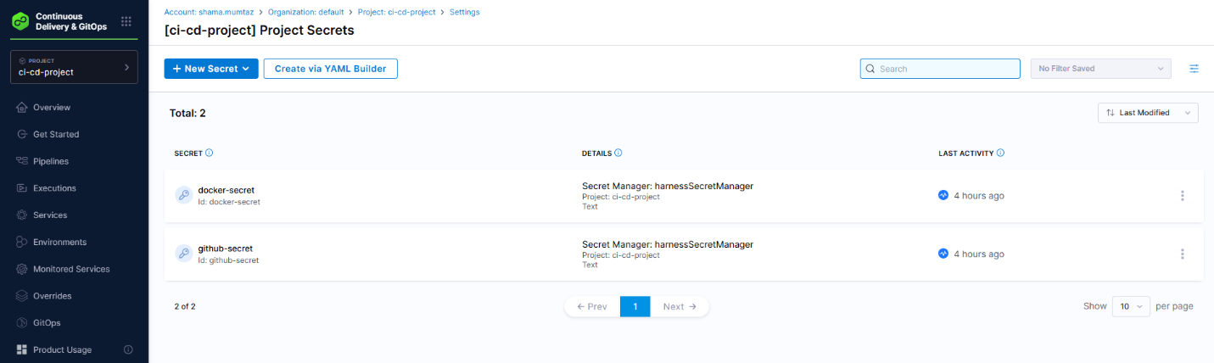
Step 4 — Add Connector:

4.1 GitHub connector:
Usage: Enables Harness to clone your repository.
- Go: Project Settings → Connectors → New Connector → GitHub.
- Choose URL Type: Repository (or Account if you want to allow many repos).
- Auth: GitHub App (recommended) or Personal Access Token (PAT). If PAT, reference GITHUB_PAT secret you created.
- Test connection and save. (Harness docs for GitHub connector/GitHub App). (Harness)

4.2 Docker Hub connector:
Usage: Enables CI pipeline to push Docker images.
- Go: Account Settings (or Project scope) → Connectors → New Connector → Docker Registry.
- Provider: Docker Hub (URL: https://registry.hub.docker.com if asked).
- Credentials: use DockerHub username + password/DOCKERHUB_TOKEN secret.
- Save & test. (Harness Docker registry connector doc). (Harness)
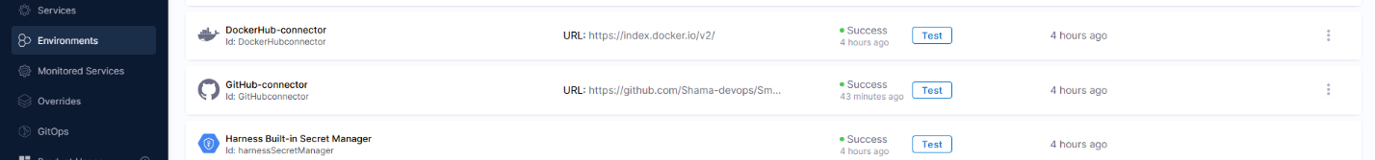

4.3 Kubernetes Cluster connector (Minikube):
Usage: Delegate bridges SaaS Harness with Minikube for deployments.
Two options:
- (A) Kubernetes Connector using kubeconfig — only works if Harness Manager can reach the cluster (rare for Minikube behind NAT).
- (B) Recommended: install a Harness Delegate in the Minikube cluster and create a Kubernetes Cluster connector that uses the delegate. This is the normal approach for on-prem/local clusters (Harness Delegate acts as the bridge). See Delegate docs below. (Harness)

Step 5 — Install Harness Delegate (required for Minikube):
Because your Minikube is local/private (on EC2), install a Harness Delegate into the cluster so Harness (SaaS) can perform deploy/build tasks there.
Objective: Allow Harness SaaS to control Minikube cluster on EC2.
Usage: Delegate enables CI/CD tasks on a cluster that is behind NAT or local.
Steps:
- Account Settings → Account Resources → Delegates → New Delegate → Kubernetes → Kubernetes Manifest
- Copy YAML → save as harness-delegate.yml
- Apply in Minikube:
kubectl apply -f harness-delegate.yml
- Verify pods:
kubectl get pods -n harness-delegate-ng
Important: the Delegate must be able to access the cluster API and DockerHub (for push/pull if used there). (Harness).

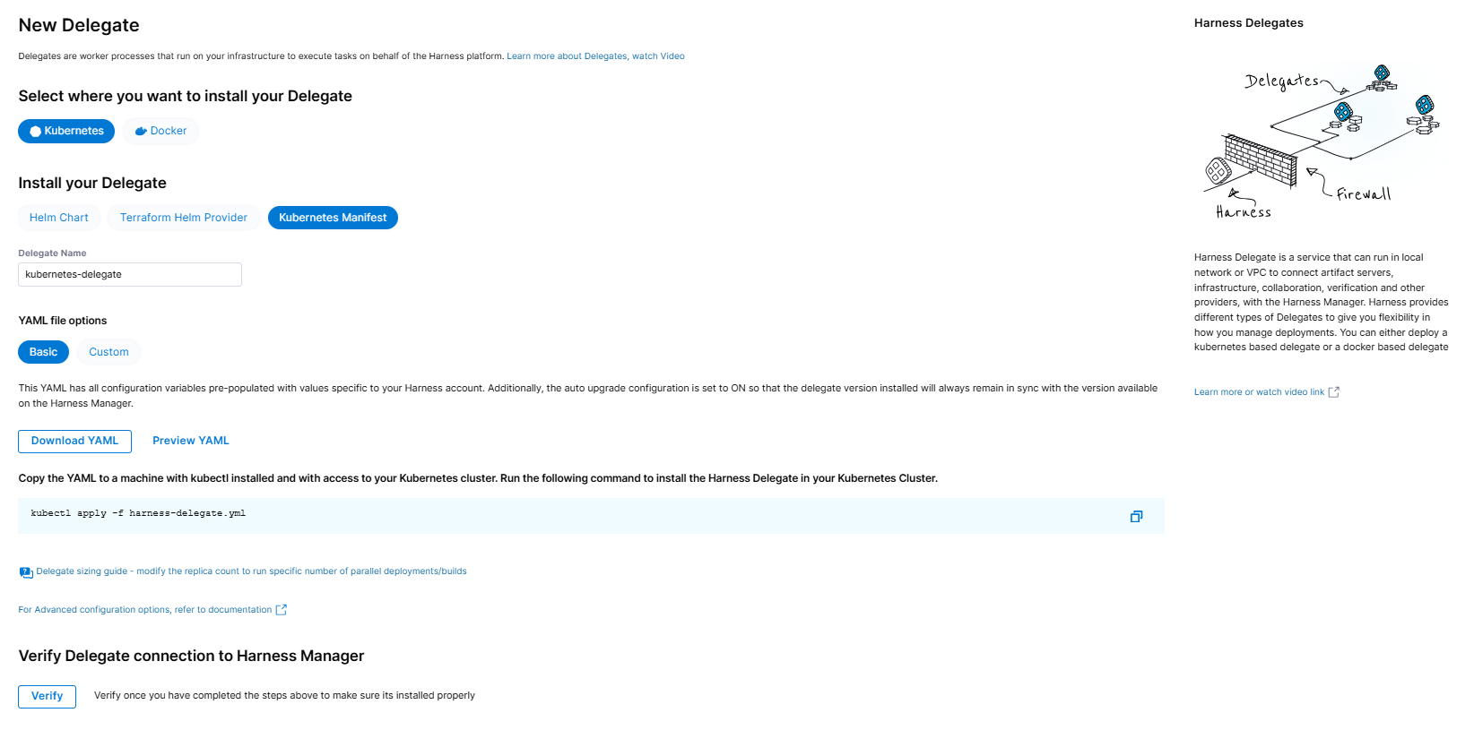
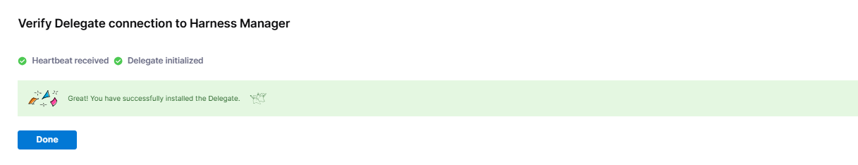
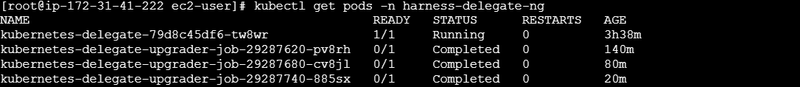

Step 6— Create the CI pipeline in Harness:
- In Harness: choose Continuous Integration (CI) module → Pipelines → +Create Pipeline.
- Name: spring-ci → choose Inline (Harness stores pipeline).
- Add Stage → Build. In the Build stage settings: Enable Clone Codebase and select the GitHub connector + repo: https://github.com/Shama-devops/Smallest-spring-boot-sample. Choose branch (master or main).
- Inside Build stage, add steps in order:
a. Run Maven Build & Test:
Objective: Compile Java app, run unit tests, produce target/*.jar.
  - Step type: Run
  - Script: bash
cd SmallestSpringApp
mvn -B clean package
mvn -B test
b. Build & Push Docker Image:
Usage: Pushes containerized Spring Boot app to Docker Hub automatically.

Add Dockerfile to your repo (if not present)
# Dockerfile
FROM eclipse-temurin:11-jre as runtime
WORKDIR /app
COPY target/example.smallest-0.0.1-SNAPSHOT.jar app.jar
ENTRYPOINT ["java","-jar","app.jar"]
Explanation:
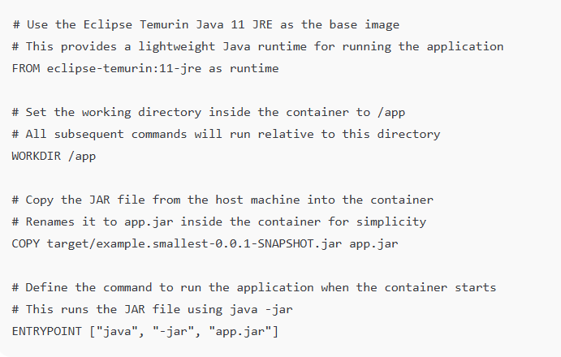
Steps:
- ConnectorRef: select your Docker Hub connector
- Repo: your_dockerhub_username/repositary_nm
- Tags:
- Example: latest, ${BRANCH_NAME}, v1.0.0
- Purpose: Docker images are identified by repository + tag.
- Objective: Tag allows you to manage multiple versions of the same image.
- Dockerfile: Dockerfile
- Context: SmallestSpringApp
- Purpose: Directory containing all files needed for building the image.
- Example: . (root folder of repo)
- Objective: Docker can only access files inside this folder. It cannot copy files from outside this context.
- (If your build infra is Kubernetes, Harness uses kaniko behind the scenes — kaniko may require root access; see docs if you hit permission errors). (Harness)
- Save the stage and Pipeline. Optionally add a Post stage to run integration tests (pull the pushed image and run it in a k8s pod or docker) — Harness can run integration tests as a separate stage.
Make sure Clone Codebase is ON in the Build stage so the JAR built in the Run step is available to the BuildAndPush step (workspace sharing). See CI Run steps & Maven examples. (Harness)
Step 7 — Kubernetes Manifests:
Objective: Define deployment and service for Kubernetes cluster.
Repo path: k8s/springboot/
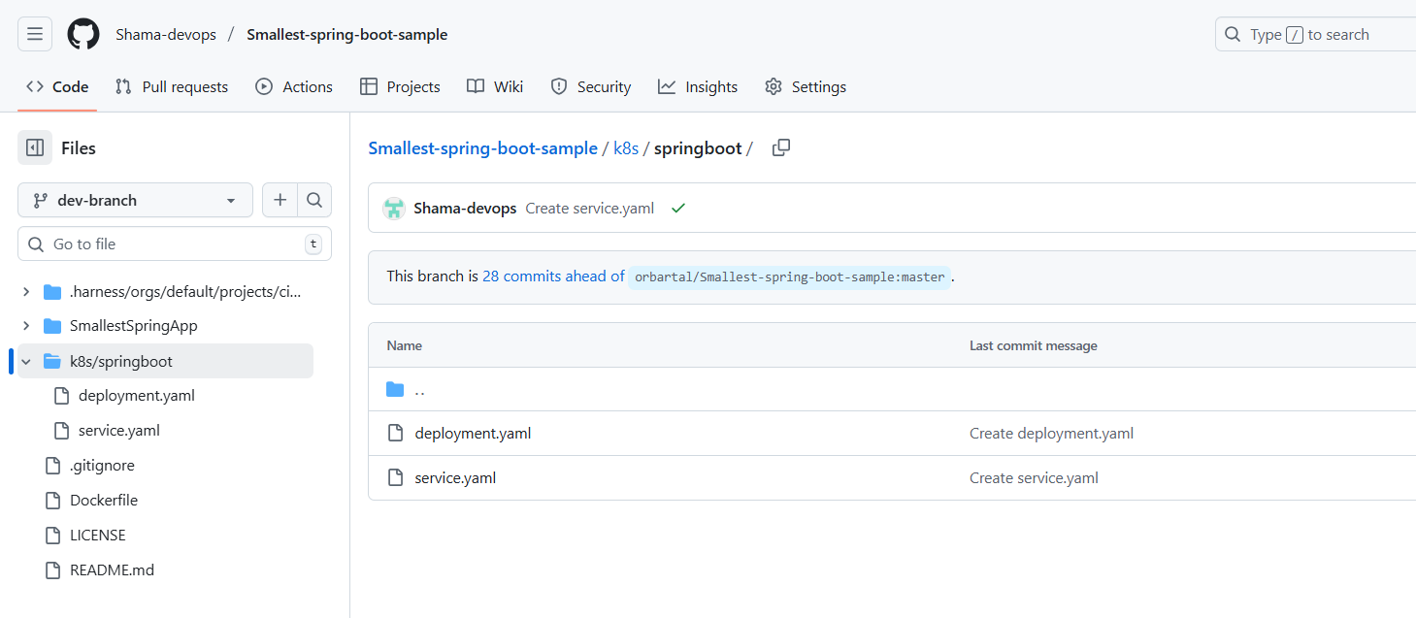
Create k8s/springboot/deployment.yaml:
apiVersion: apps/v1
kind: Deployment
metadata:
name: springboot-app
spec:
replicas: 1
selector:
matchLabels:
app: springboot-app
template:
metadata:
labels:
app: springboot-app
spec:
containers:
- name: springboot-container
image: shamamumtaz/springboot-sample-repo:v1.0
ports:
- containerPort: 8080

Create k8s/springboot/service.yaml:
apiVersion: v1
kind: Service
metadata:
name: springboot-service
spec:
type: NodePort
selector:
app: springboot-app
ports:
- protocol: TCP
port: 8080
targetPort: 8080
Usage: Defines how pods are created and exposed.
Note: Replace DOCKER_USERNAME with your Docker Hub username (or set the image path in Harness CD configuration to the connector and let Harness replace the tag at deploy time). Harness supports linking manifests in Git and substituting image tags during runtime. (Harness)
Step 8 — CD Setup:
Objective: Deploy the Docker image into Minikube using Harness CD.
Usage: Automates deploying your Docker image to Minikube whenever CI succeeds.
Steps:
A. Create Service (Kubernetes):
What it is:
- In Harness, a Service represents the application or microservice you want to deploy.
- It defines what to deploy, including artifacts (Docker images, JARs) and Kubernetes manifests (Deployment, Service, ConfigMaps, etc.).
Why we create it:
- It tells Harness “Here is my Spring Boot app, here’s its container image, here’s how it should run in Kubernetes.”
- Without a Service, Harness doesn’t know what to deploy.
In Harness: go to CD (Deployments) → Services → Manage Services → New Service.
- Select inline
- Name: smallest-spring-service → Service Definition → choose Kubernetes.
- Under Manifests → Add Manifest → select K8s Manifest → choose Git as the Store and point to the k8s/ folder in your repo (select the GitHub connector and repo branch).
- Add both deployment.yaml and service.yaml. Harness can fetch them at deployment time. (Harness)
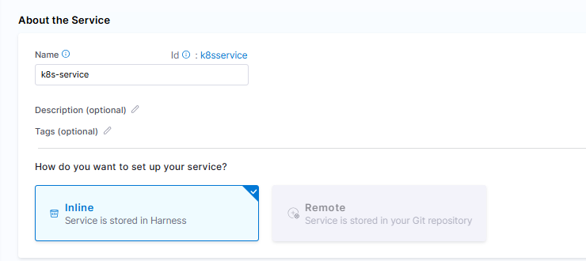
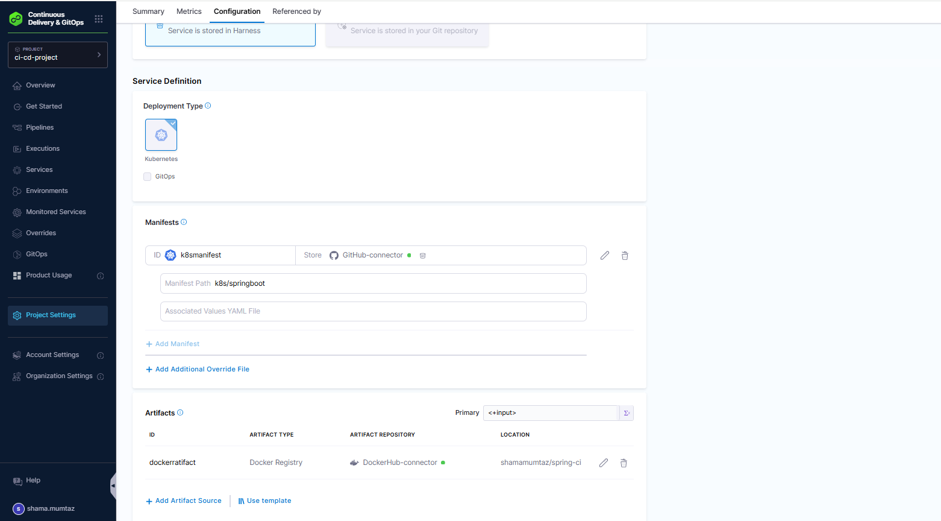
B. Environment & Infrastructure Definition:
What it is:
- An Environment represents where your service will be deployed.
- It can represent dev, staging, production, or in your case, Minikube cluster on EC2.
Why we create it:
- It separates deployment targets and configurations, so the same Service can be deployed to multiple environments with different settings (replicas, resources, namespaces, secrets, etc.).
- Without an Environment, Harness doesn’t know where to deploy your Service.
Environment → New Environment. Name: Minikube-Dev.
- Add Infrastructure Definition → Type: Kubernetes Cluster → Choose the Kubernetes connector you created (the one that uses the Delegate you installed).
- Select namespace (e.g. default or your-namespace).

Infrastructure Definition:
What it is:
- Infrastructure tells Harness how to connect to the actual target cluster, including:
  - Kubernetes cluster connector (delegate)
  - Namespace to deploy to
  - Any cloud or on-prem specifics (like Minikube node, cloud region, VPC, etc.)
Why we create it:
- Separates deployment logic (Service) from cluster details (Infrastructure).
- Enables reuse: you could deploy the same Service to multiple environments/infrastructure (dev cluster, prod cluster) without modifying manifests.

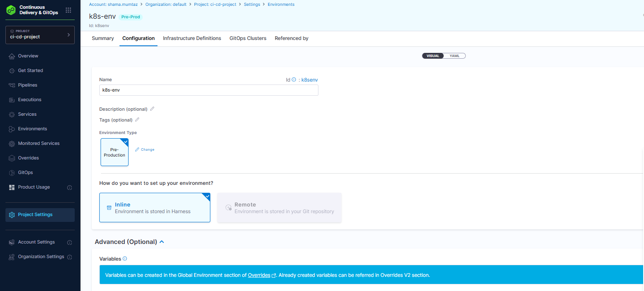
C. Create a CD Pipeline:
- CI Pipelines → Add a Deploy stage.
- Add Service = smallest-spring-service, Environment = minikube-dev.
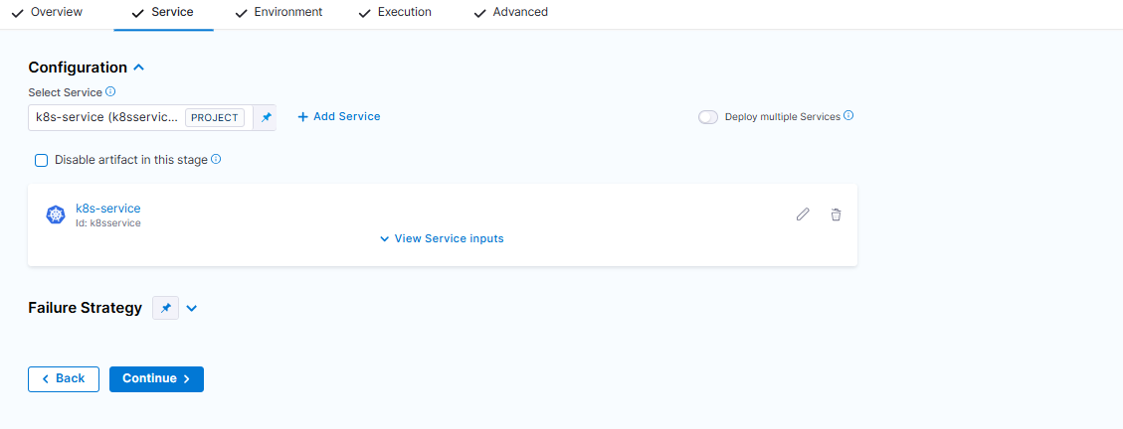
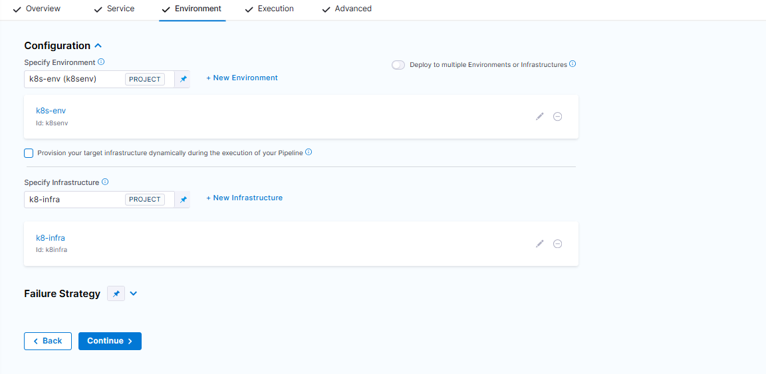
- In Artifacts, map the artifact to the Docker connector image you pushed in CI (Harness can automatically pick the latest tag or you can supply the tag from the CI run e.g. <+pipeline.sequenceId>).
In the pipeline you can configure the exact tag to substitute into the manifest (Harness supports runtime variables and manifest image replacement). See “Add Kubernetes manifests” and using Git-backed manifests. (Harness)
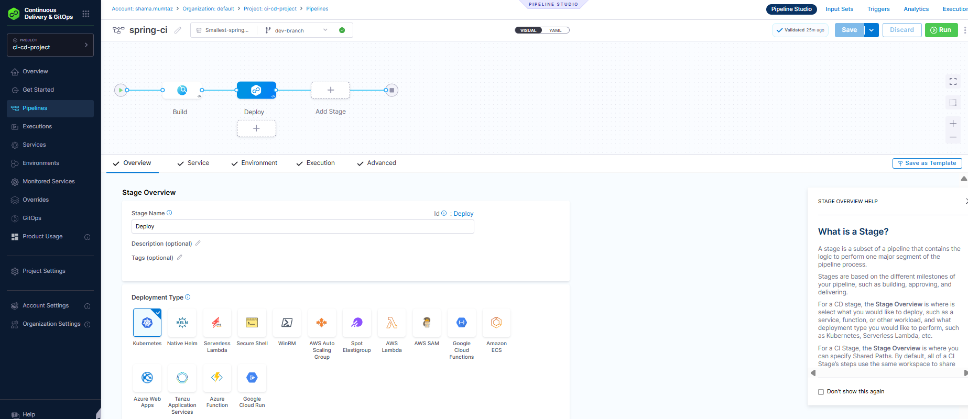
Step 9 — Access Application:
On the Minikube host (or with kubectl configured for that cluster):
- Check pods: kubectl get pods -n <namespace>
- Check service: kubectl get svc
- To open the app locally on Minikube machine:
- minikube service smallest-spring-svc --url (prints URL)
- Or kubectl port-forward svc/smallest-spring-svc 8011:8011 and open http://localhost:8011
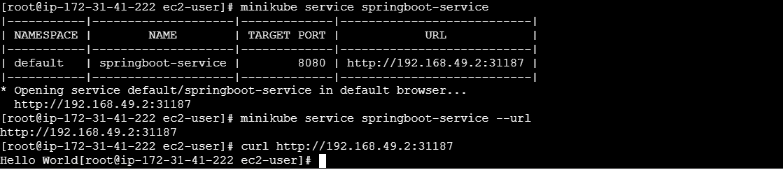

How to access your Spring Boot app externally:

Option 1: Use minikube tunnel (for LoadBalancer)
- On EC2, run: minikube tunnel
- Creates a routable IP for LoadBalancer services.
- You can change your service type to LoadBalancer:
spec:
type: LoadBalancer
- Then get external IP:
kubectl get svc springboot-service
- Use the external IP to access the app from your browser.

Option 2: Use kubectl port-forward (quick test)
- Forward local EC2 port 8080 to the pod:
kubectl port-forward svc/springboot-service 8080:8080
- Then on EC2 (or your laptop via SSH tunnel):
curl http://localhost:8080

Option 3: SSH tunnel from your laptop
- From your laptop, create a tunnel to EC2:
- Run minikube service springboot-service –url and set the tunnel
ssh -i KP-2207-EB.pem -L 8082:192.168.49.2:31733 ec2-user@<EC2-Public-IP>
- Open browser:
http://localhost:8082
- This forwards Minikube NodePort to your laptop.
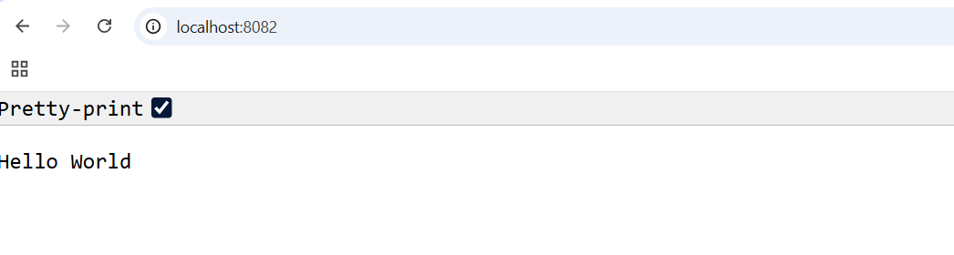
Summary:
- minikube ip gives internal Minikube IP → not the EC2 public IP.
- NodePort on Minikube cannot be accessed directly from outside without tunneling or a LoadBalancer.
- For external access, either:
  - Change Service to LoadBalancer + minikube tunnel, or
  - Use SSH tunnel / kubectl port-forward.

Troubleshooting tips (most common issues):
- Build fails / no JAR for Docker: Ensure the mvn package Run step runs in same workspace and completes successfully before BuildAndPush. Enable Clone Codebase for the stage. (Harness)
- Docker push fails: Verify Docker Hub connector credentials and that the Delegate (or build infra) can access Docker Hub. Create a Docker Hub access token and use it as secret. (Harness)
- Harness can’t reach Minikube: Check the Delegate is installed and healthy in the Minikube cluster (pods running in harness-delegate-ng). Delegate logs show connection status. (Harness)
- Kaniko / permission issues: If your build infra is k8s, BuildAndPush may use kaniko which needs root; Harness doc has guidance. (Harness)
- Create CD Service + Environment + Deployment pipeline that pulls manifests from Git (or inline manifests) and deploys using the Kubernetes connector. (Harness)
- Test: push to repo → CI triggers → Docker image appears in Docker Hub → CD deploys to Minikube → confirm app is reachable.

